**Soloros – Second Year Group Project Report**

Group Members: Saurab Chhachhi, Pavitar Devgon, Kartiksinh Gohil, Vidushan Jeyanesan, Mart Luide, Tom Priddle, Hiranya Seneviratne

Supervisor: Dr David Angeli

**Abstract**

The demand for electricity, especially in the developing world is increasing rapidly as populations grow and consumer electronics become cheaper. In August 2012 over 300 million people were left without electricity when India’s northern gird collapsed. This deficit in the energy supply is shared by most countries in Asia, severely limiting people’s lifestyles, especially in education since computers are now an essential part of competencies in all fields. However a recent study has shown that the greatest reservoir of potential solar power generation is right on Asia’s doorstep: The Himalayas.

The main barrier has been transmitting this power to the urban population centres. In order to solve the energy crisis in a truly renewable and sustainable manner, the solution proposed is to build a system where solar power generated in the high altitude environments is transmitted, using microwave technology, to connect to existing grid networks.

Table of Contents

1. Introduction 3

1.1 Background 3

1.2 Project Scope and Goal Identification 3

2. Research and Planning 3

2.1 Background Research 4

2.1.1 Energy Demand and Consumption 4

2.1.2 Power Production Technologies 4

2.1.3 Cable Transmission Systems 4

2.2 Technical Research 4

2.2.1 Generation 4

2.2.2 Microwave Transmission 5

2.2.3 Grid Connection 6

3. Finalized System 7

4. Mathematical Model 7

4.1 Description of Model 7

4.1.1 Weather Modelling 7

4.1.3 Transmission Modelling 9

5. Cost Feasibility Study and Environmental Impacts 10

6. Project Evaluations and Further Development 11

7. References 11

Appendix A – Locational Information 13

Site Profile 13

Line of Sight Calculations 14

Appendix B – Transmission Figures 15

Appendix C – List of Variables used in Modelling 17

Appendix D – Mathematical Model Output 19

# 1. Introduction

## 

## 1.1 Background

Electricity is becoming an increasingly essential resource for countries to function with the continuous automation and digitisation of industries and services. With over 56% of the world’s population, Asia has been booming economically, but has been struggling to meet the drastic increase in energy demand associated with this growth. In most developing nations this problem has been attributed to the lack of infrastructure and technical knowledge. However, in China and India, arguably two of the most influential emerging economies, the electricity problem has been one of supply rather than transmission. The Indian government has been focusing heavily on nuclear and hydroelectric power to meet the rising demands.[1] Plans for a number of new nuclear power stations in India have been met with heavy resistance from the local population, citing the recent nuclear disaster in Fukushima, Japan. China’s heavy reliance on coal highlights another problem with this form of energy generation: it is neither renewable nor sustainable. Solar power meets both of these criteria and the greatest potential supply of it is towering 8000 metres above them: The Himalayas.

In 2011, a group of Japanese researchers examined the photovoltaic (PV) energy potential across the globe and found that the best places for this type of power generation are the high mountains of the Himalayas and the Andes.[2]The research highlighted the following advantages for generating power from these mountains:

1. At high altitudes PV cells would produce 20% more energy than if they were at sea level, since at this elevation less solar radiation is lost to the atmosphere.
2. PV cells are more efficient at lower temperatures. Although hot deserts are considered to be the ideal place for solar power production, the high temperatures of almost 50 °C mean current crystalline silicon solar arrays are 13% less efficient due to heat loss. Estimates from the study have suggested that PV modules in the Himalayas could be overall 50% more efficient than in the desert.
3. Covering less than 4% of the Himalayan region with these solar arrays can potentially result in a production of 3.1 trillion kWh. This was the annual electricity consumption of China in 2007.

The main challenge in the proposed system is how to get this generated power from the high mountains down to the main grid. There are a number of possibilities including conventional overhead cables, subterranean cables or through wireless transmission. Wireless power transmission using microwaves, if shown to be viable and efficient, could be the most fitting solution as it could be physically easier to implement, than laying cables.

## 1.2 Project Scope and Goal Identification

This project will be a feasibility study for a small scale power plant located within the remote Himalayan region which will transmit solar-generated power to an existing grid network. The foundations outlined in this report could be taken further and be scaled up to a pilot plant prototype. The project is focused on evaluating whether existing technology and current research can be used to implement the proposed system. This will be done considering the technological feasibility and economic cost as well as possible social and environmental externalities.

Using research discussed in the next section, it was decided to target the energy demands of Nepal. Compared to larger countries in the region like China, India or Pakistan, Nepal is the ideal place to test the system as the country is relatively small with a population of 30 million and an area of 148 km2.[3] This allows a simulation of the proposed system on a manageable scale. In terms of the system itself it was decided a 1 Megawatt (MW) solar power plant is needed to be implemented as a realistically achievable goal. Initially this may not seem significant, but if proved feasible, the idea could be easily expanded to increase the supply capacity. The power will be transmitted from the power plant in the mountain, as microwaves, to receivers located closer to the population centres where the grid infrastructure will take over.

# 2. Research and Planning

The proposed system encompasses a number of independent subsystems of the energy production industry. The research effort was divided into two fields. The first field covers the existing energy infrastructure in the targeted regions, while the second focuses mainly on the technical information required to design the system.

## 2.1 Background Research

### 2.1.1 Energy Demand and Consumption

Currently only 48% of the Nepalese population have access to electricity and the country still struggles to reliably supply electricity to this grid-connected population. From 2001 to 2011 the peak power demand has more than doubled from 391 to 946 MW and has resulted in the need for load-shedding which has meant up to 14 hour power outages in the capital city, Kathmandu. The Nepalese Electricity Authority (NEA) have estimated at current annual demand growth rates of 8.34%, the annual energy demand will double to around 8860 Gigawatt-hours (GWh) by 2018. [4] To meet these demands the NEA have targeted to reach 10,000 MW of installed power plants by 2020. However due to slow deployment and financial constraints it is unlikely that this target will be met.

### 2.1.2 Power Production Technologies

Energy production in Nepal can be split into three sources: Hydroelectric, Thermal and Imports. Of the currently installed capacity in Nepal, 83% is generated from hydroelectric power plants and this is where the government plans to focus its investments. From government surveys it has been estimated that there are approximately 42,000 MW of hydroelectric power resources available in Nepal and have been classified as feasible. Nevertheless, they incur high initial development costs due to the landscape as well as the impact on climate change. Currently, there is 652 MW installed capacity of hydroelectric power, but the average output of these power plants varies seasonally, especially in the dry season when power output drops drastically. It is uncertain how glacial retreat and changes in rainfall patterns, resulting from climate change, will affect Nepal’s water security in the future. [5] The other major energy supply has been the imports from India which have tripled over the last decade. This is very unsustainable as India faces its own energy deficit and may not be able to continue to supply Nepal in the future. In order for Nepal to meet its rising demands a different energy source is required, which is where solar power could provide a reliable and self-sufficient energy production system.[1]

### 2.1.3 Cable Transmission Systems

Current electricity transmission technologies can be split into two main types; conventional overhead transmission and undergrounding. As we are aiming to provide 1MW to the grid we will require at most a 33kV line which is categorized as a distribution line and costs will be much lower than most high-voltage transmission lines. A study conducted in 2012 compared the feasibility of overhead and underground transmission lines at different lengths and capacities resulting in some interesting figures. [6] It found that underground cables even when buried in the ground are on average 10 times more expensive than overhead lines of the same capacity and length. Underground cabling and installation at around £17.8 million (m) alone cost considerably more than overhead lines at £1.9m. This is a huge drawback to undergrounding in the Himalayas which would add significant costs reflected by a recently built road tunnel for in the Himalayas costing around £200 million.[7]Another factor to consider is the reliability of the system which can be measured by looking at the number of power outages caused by cable faults as well as the time taken to fix them. A study conducted over a five year period found that areas served by underground cables suffered 50% fewer power outages however the duration of the outages were on average 58% longer. [8] This increase in repair times and maintenance costs meant that overhead lines which were over 40 years old were more reliable than underground cables half as old. Although overhead lines are prevalent in Nepal the terrain is such that the costs are significantly increased due to the civil works required to keep the pylons secure in the event of landslides and avalanches. This has also meant that of the 48% of the population which have access to electricity only 8% are in rural areas. [9] Both these methods face a number of obstacles on high altitude terrain which is where wireless power transmission[2] could offer a more viable solution.

## 2.2 Technical Research

The system has been split into three modules: Generation, Transmission and Grid Connection.

### 2.2.1 Generation

Solar power generation has been growing rapidly over the last 10 years with increased efforts to provide clean and renewable energy. However, it has had some major drawbacks resulting from its considerable initial costs and the conversion efficiency of the photovoltaic cells. There are currently four main commercially available PV cell types:

* Monocrystalline Silicon PV
* Polycrystalline Silicon PV
* Amorphous Silicon PV
* Hybrid Silicon PV

Each of these has a number of advantages and disadvantages which have been summarised in the table below. [10]

|  |  |  |  |  |
| --- | --- | --- | --- | --- |
| **Silicon based PV** | **Efficiency**  **(%)[3]** | **Energy Output (kWh/kWp) [4]** | **Size**  **(m2)[5]** | **Cost**  **(£ per m2)** |
| Monocrystalline | 13-17 | 800 | 25 | 600 |
| Polycrystalline | 11-15 | 750 | 30 | 500 |
| Amorphous | 6-8 | 850 | 50 | 350 |
| Hybrid | 18+ | 900 | 20 | 800 |

Table 1 – Characteristics of silicon based PV cells.

As the solar power plant will be located on the high altitude plateaus of the Himalayas, there are a number of unique factors to consider. These include spatial constraints and extreme weather conditions. The amorphous PV cells are very flexible and can even be used on curved surfaces which could be beneficial in the Himalayas, where there are rapid changes in gradient. However, their low efficiency would require a larger spatial area to be covered, making them an undesirable option. Hybrid cells have high efficiencies as they use multiple PV technologies on a single panel, but unlike most PV cells they perform better at higher temperatures. This, together with their cost premium, makes them unsuitable for use in the system. The main advantage of polycrystalline cells is their non-reflective property, resulting in greater output even in low light conditions. However, monocrystalline PV cells are more suited for the system as they have comparatively high efficiency and also benefit from the lower temperatures present in the Himalayas. In addition, their durability in extreme weather conditions makes them ideal for low maintenance requirements. The cells found to be modelled, produced by the Sunpower company (discussed later), were at the higher end of the cost spectrum, but cheaper brand could be used if the total quantity cost was too large.

### 2.2.2 Microwave Transmission

Wireless power transmission(WPT), first predicted by Maxwell in 1873 and then confirmed by Hertz with his experiments on radio waves, was strongly supported by Nikola Tesla in the 20th century[11] who showed the feasibility of the concept with his experiments in 1899 at Colorado Springs[12][13]. There was a relative lack of interest for decades after that and it was only revived with the invention of the magnetron in the 1939[14] and the development of radar for military use in the Second World War which led to the invention of rectennas in the 1960s. There were experiments which tested the feasibility of WPT such as the microwave powered helicopter [15] in the 1968 which led to the proposal of space-based solar power satellite (SSPS) and further studies and funding during the 1970s. During that time, under the guidance of Raytheon at the NASA JPL and the Goldstone facility in 1975, there was a higher power microwave experiment was performed, achieving over 80% rectification efficiency [16] with 30kW output. Even longer range (120km) experiments have been conducted between two islands in Hawaii in 2009 and 2010[17] [18]. The common microwave ovens magnetrons efficiency is approximately 70% [19] while specific magnetrons can reach efficiencies up to 87%. The rectifying antenna (rectenna) efficiency peaks at about 85% to 90% [20].[6] There has been significant research done towards near-field WPT, mainly with the aim of powering household and consumer electronics but as this topic is not the subject of this study we concentrate more on the far field transmission related research. Optical WPT also became a possibility after Theodore Maiman developed the first laser in 1960. Laser WPT is attractive in certain applications but also has far lower far-field efficiencies compared to microwave transmission which is the reason why we decided to go forward with microwave WPT in our study.

We decided to use the NASA model for the Magnetron Directional Amplifier (MDA) which in essence is a typical magnetron combined with a passive directional device (“magic T”) and is equipped with added output sensors and compensators for amplitude and phase tracking together with feedback control circuits [21]. The conventional magnetron used for the MDA is composed of pyrographite cooling fin, the buck-boost coil, the magnetron tuner with solenoid, and the samarium cobalt magnets (Figure 1)

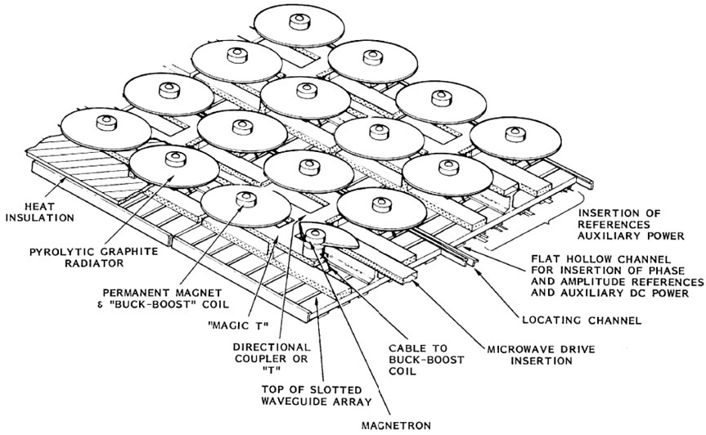

Figure 1 – Magnetron Directional Amplifier (MDA) SSP Sub-array design [22]

This configuration is preferable since it will provide:

* Phase and amplitude tracking capability of magnetron directional amplifier
* Exceptionally high signal to noise ratio
* Long life based because of low operating temperature of the carburized thoriated tungsten cathode

The phase and amplitude tracking control circuit is shown in Figure 5 in the Appendix B. Their operation is relatively complex by itself but the JPL model would be capable of phase tracking within +/- 1 degree and output amplitude tracking within +/- 30%. In the experiment that they conducted they observed 20dB gain. This tracking requires auxiliary DC power but on the generation side this can be achieved by rectifying a portion of the generated microwave power. These power modules are also useful since the can split the power from the PV evenly and perform their own DC to RF power conversion. This is good since designing a single magnetron with a capability to intake 1MW could provide to be difficult. The size of the current radiating unit is 77.48cm by 36.83cm.

The IEEE standards for maximum permitted radiation exposure of microwave radiation at 2.45 GHz is 81.6W/m2 or 100W/m2 as averaged over 6 min, and 16.3 W/m2 or 38.7 W/m2 over 30 min for controlled and uncontrolled environments respectively[23]. In our systems we aim to have over 70% efficiency over the transmission link to demonstrate the feasibility of the WPT. The location data can be found in the Appendix A and the distance that we have chosen between the antenna and the rectenna is 26.02km. To achieve this level of efficiency the directivities of the two have to extremely high (>10^6) and therefore the arrays have to be aligned.

### 2.2.3 Grid Connection

When connecting a variable energy source, like solar power, to a grid network, there are a number of factors which must be considered:

1. Intermittency: The extent to which the power source has an undesired or uncontrolled output.
2. Dispatchability: The ability for the power source to match output to the system demand.
3. Nominal Capacity: The maximum rated output of the system.
4. Penetration: The percentage of annual consumption the power source will generate.

Solar power has a relatively high intermittency as it only produces power during the day and its efficiency is highly dependent on the weather, which means it is considered to be unreliable. Its dispatchability is also inherently low as peak demands usually occur during the evening and night, when solar cells will be producing effectively no power. Both of these problems can be solved with the introduction of large-scale grid energy storage.

Before investment in renewable sources, load balancing was done by varying the output from power plants. In a solar plant there is no control over the power output, so matching demand and supply becomes a problem. By introducing flow batteries, which provide large scale storage, power can be supplied when required, even when a rapid-response is needed. Coupled with advancements in load balancing technologies and possible implementation of smart grids, solar power can be reliably connected to the existing network without having to redesign the functioning of the system. This will, no doubt, add costs to the generation of electricity from these sources but, according to a study conducted by the U.S. Department of Energy [24], the increased costs would vary from £2.31/MWh to £4.71/MWh.[7]

# 3. Finalized System



Solar

Irradiance

Photovoltaic Cells

DC-DC

Converter

Flow Batteries

Inverters

Grid

Microwave Transmission

1MW Solar power plant in Banglung Pani with 3000 solar panels. After DC step-up power is fed to transmitter array.

2500m2 transmitter array transfers power at 2.45GHz to 2500m2 receiver in Pokhara 26 km away.

From receiving array energy is stored in a 5 MWh Zinc-Bromine flow battery.

Using load balancing technologies power is supplied when required to existing grid in Pokhara.

Figure 2 System Overview

# 4. Mathematical Model

## 4.1 Description of Model

### 4.1.1 Weather Modelling

The weather model was an important part of the project overall, as it would determine the amount of direct solar irradiance received by the photovoltaic cells. There were a host of suitable weather models, but they only accounted for the solar irradiance at sea level. This was a problem because the biggest benefit of the proposed solar power plant was its location in the mountains, which would hopefully reduce the quantity of light scattered or absorbed by the atmosphere. In order to account for this in the simulation, an additional research paper[25] was used: the authors discussed how the solar irradiance increased as a function of altitude, using the Altitude Effect (AE).This will be further detailed after explaining the initial weather model.

The model that chosen to employ was from a research paper published for the American Meteorological Society [26], which would output the direct solar irradiance at different wavelengths, producing a spectral analysis for each day of the year. The input of the model was the solar zenith angle, which is the angle of the Sun from the vertical.

$$I_{dλ}= H_{oλ}T_{rλ}T_{aλ}T_{wλ}T_{oλ}T_{uλ}D$$

The above equation was simulated using MATLAB. $D$ represents the earth-sun distance factor and is dependent on the day of the year. $H_{oλ}$ represents the intensity of solar irradiation directly outside the earth’s atmosphere and was given as a parameter in the paper. The other variables, which represent the transmittances for different types of scattering and absorption that occur in the atmosphere, are functions of the wavelength and the zenith angle and were given in this and other papers. [27] The zenith angle itself is a function of the day. [28] A full list and definition of variables can be seen in Appendix B. As a result, $I_{dλ}$, the direct irradiance, is also dependent on both the wavelength and the day of the year, allowing a realistic simulation to be created of how the irradiance varies throughout the year. More details on variables defined above and the weather model can be found on the website[8].

Having successfully implemented the basic weather model, the altitude effect was applied to the output. The altitude effect is caused by electromagnetic radiation travelling to sites at higher altitudes than sea level, and hence undergoing less scattering and absorption by the atmosphere.

$AE(\%)=(\frac{I_{m}}{I_{v}}$– 1) x ($\frac{∆Altitude(m)}{1000m})$ x 100%

The altitude effect is expressed as a percentage per 1000 metres, given as a function of direct irradiance at the mountain site (Im), the valley site (Iv) and the change in altitude between them in metres. The research paper concluded that the altitude effect on average was 8%±2% per 1000 metres, which could be applied to most locations. Therefore, setting the output of the basic weather model as the valley irradiance and using an AE value of 8%, the model was able to ascertain the direct irradiance at the mountain site.

The resulting graph is as expected with most of the irradiance concentrated in the visible light spectrum. Also there are large troughs associated with absorption characteristics of the earth’s atmosphere. However the peak amplitude for irradiance achieved was 900W/m2 which is slightly less than the 1000W/m2 estimate commonly used.

4.1.2 Photovoltaic Cell Modelling

To model the photovoltaic (PV) cells, the data sheets of the E20/333 model cells, produced by the Sunpower company, were used.[29] The data sheet provided the open circuit voltage and short circuit current, among other things, which could be used to plot current-voltage (IV) and power-voltage graphs. The parameters were quotes for an optimal irradiance of 1000Wm-2, so were scaled to find the appropriate value for the mountainside irradiance.

The equations shown below model the current and voltage of a single PV cell. [30] The photocurrent (Iph) is the current generated by the irradiance incident upon it, and relies on many parameters given in the report cited. The diode current (Id) is given in the standard form, and is used because of the semiconductor properties of the cell, and the resistance current (IR) takes into account loss factors. These combine to give the total current out. A full list and definition of variables can be seen in Appendix B.

|  |  |
| --- | --- |
| $$I= I_{ph}-I_{d}-I_{R}$$ | $$I_{ph}= I_{sc}\left(1+\frac{R_{S}}{R_{sh}}\right)+I_{S}\left(exp\left(\frac{I_{sc}R_{S}}{V_{th}n^{'}}\right)-1\right)$$ |
| $$I_{d}=I_{S}\left(exp\left(\frac{V+IR_{S}}{V_{th}n}\right)-1\right)$$ | $$I_{R}=\frac{V+IR_{S}}{R_{sh}}$$ |

A simulation was then created in MATLAB, modelling over a range of voltages (from zero to just above the open circuit voltage) and the corresponding currents. An efficiency term was also needed, as the cells to be modelled had, at best, 21% efficiency.

The IV characteristic was plotted to check the outputs of the model, and when the accuracy was sufficient, the power output was found. This also varied with voltage so in order to get a single usable value, a common solar cell method was applied: maximum power point tracking. In a physical system, this is used to optimise output to the highest possible power. The simulations simply located the maximum value in the power vector.

This maximum power was given from a single cell, so by designing an array with multiple cells in series and parallel, the power would be added together. Joining together in series increased the total voltage across them, while a parallel placement increased the current. The dimensions of the array were added to the model to scale the power. Another research paper, by Sunpower, provided a graph showing the cell’s reaction to different wavelengths. [31] This was corroborated with another, independent research paper on the absorption properties of PV cells. [32] Combining both provided a percentage weighting factor to multiply to the power at each wavelength. After these additions, the output the model provided was the total maximum power generated by the array for the given irradiance.

Initially, a surface plot was used to portray the power, but the data points were too close packed and widely fluctuating so it was difficult to see trends. Instead, a simple line graph was created when the power was averaged out over all wavelengths. This provided a good estimate as to what the total power was expected to be on the given day should be and enabled a power against day graph to be plotted[9]. With an array of 10,000 PV panels the daily power output varies considerably through the course of a year from 1.4kW in winter to 1.2MW in summer.

### 4.1.3 Transmission Modelling

Our transmission model is mostly derived from the Friis Formula with $η_{T}$, $η_{Rect}$, $η_{A }$ values based on previously found experimental and theoretical values(Appendix B Figure 8). We first solve for the needed $D_{T}D_{R}$ product for our efficiency $η_{Beam}$ and then estimate the values for $D_{T}$ and $D_{R}$ individually that would make it possible to achieve that. Finally we have to model a system in the physical world that would be able to achieve such values for directivity and efficiency.

$$\frac{P_{R}}{P_{T}}=η_{A}η_{T}η_{Rect}η_{PM}\left(PCE\right)D_{T}D_{R}{\left(\frac{λ}{4πR}\right)}^{2} D_{T,R}=\frac{4πU\left(θ,ϕ\right)}{\int_{0}^{2π}{\int_{0}^{π}{U\sin{θdθdϕ}}}}$$

$$η_{Beam}=D_{T}D_{R}{\left(\frac{λ}{4πR}\right)}^{2}$$

Most of our simulation was done in the MATLAB environment using an open source transmitting array simulation toolbox [33]. The toolbox uses several formulae for optimizing rectangular and circular arrays [34] of different elements. Our models were done using dipoles of with antenna spacing of 0.75 $λ$ which has been used before for similar high power microwave applications (Appendix B Figure 8). The calculations for the value of directivity of any larger antenna array require substantial amounts of computing power which significantly restricted our modelling. We considered using the MATLAB parallel computing toolbox [36] but due to the limitations of the tools and the level of simplification it require from the code were forced to abandon the idea. We made use of the MATLAB curve fitting tool [35] for initial analysis but decided to do the bulk of numerical data analysis in Excel. Directivity was calculated in both dBi (Decibel isotropic) linear values for rectangular array antennas (Figure 4) and the plotted against array size (Figure 3).

Figure 3 – Directivity dBi of a rectangular dipole array with 0.75 $λ$ spacing against array size based on element number per side.

For transmission efficiency of $η_{Beam}$ >0.7 we need the directivity product $D_{T}D_{R}$ of over $5.02×{10}^{12}$. If we split this evenly between $D_{T}$ and $D_{R}$ we will need the both to have directivities of $2.24×{10}^{6}$ or about 63.5dBi. According to our model that would require an array with approximately 565 elements per side, which is with a side length of 50.6 meters. The rectenna will be a dipole array while the antenna will be an MDA. The MDA sub-arrays are slightly larger for the same amount of elements but offer more control than the dipoles. While the MDA array would require an array on 70 meters per side for the same amount of elements we believe significant reduction in the number of elements is possible with proper amplitude and phase control. This should be one of the subjects of our further research on this topic as well as further modelling of bigger arrays.

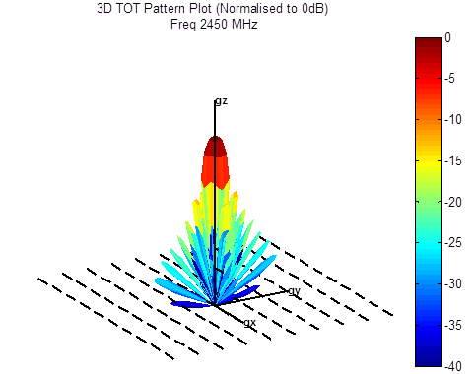

Figure 4 – 3D plot of the 2.45GHz microwave field strength of a 10 by 10 dipole array normalized to 0dB

# 5. Cost Feasibility Study and Environmental Impacts

The system installed on the mountain slopes near Banglung Pani[10] in western Nepal is rated at 1MW. To achieve this type of power output, an initial estimate of the array size was 3000 panels (with nominal power output of 333W at 1000Wm-2 irradiance). However, although in Nepal there is an additional hour of peak irradiance per day, the model[11] shows that 1000Wm-2 is never reached. To compensate, a 100x100 array of panels are needed to produce 1MW. Alternatively, a solar tracking system could be installed using low-power linear actuators which should increase both efficiency and daily energy output. By estimating a daily energy output of 5MWh, the annual contribution of 1.825 GWh would address 0.18% of Nepal’s energy deficit.

For the transmitter and receiving array, an estimate for costs can be made on a per watt basis. The system is rated at 1MW resulting in a £1.3m at £1.3/W [37]. Although the array itself is relatively inexpensive it has to be noted that the total efficiency of the system is 0.35562 taking into account conversion loses[12] and construction costs will be constitute a substantial amount of the initial investment costs and can be estimated at around £3-4m for the 50.6 by 50.6 metre arrays. This will incur a total cost of £9.3m.

An alternative to WPT which could be implemented to transmit power to Pokhara is overhead lines. Most of the costs involved in setting up a transmission line are location dependent as materials are locally sourced and labour prices vary which are summarized in a book with prices cited in Indian Rupees. [9] Taking into account all the different components required to setup a possible 40 km 33kV line the costs come to around £5.3m.

Once the power is transmitted to Pokhara grid connection technologies are required. This includes a 5 MWh Zinc-Bromine flow battery which would have to be custom built and an inverter. The flow battery costs can be estimated by combining costs of individual components detailed in a study done at MIT. [38] The system will require a 1MW/5 hour system as we only need to store a maximum of 5 MWh a day which results in a total cost of £350,000.

The total cost of the system would therefore be:[13]

* With Wireless Power Transmission: £17 million
* With Overhead Transmission Lines: £10 million

Environmental factors of the microwave radiation must also be taken into consideration when determining feasibility. The arrays used in the proposed system will have an average power density (PD) of 200W/m2 at the array sites. However this does not take into account amplitude tapering[14] caused by the array directivity. Using estimates produced by JAXA a 10dB Gaussian distribution over the surface of the array can be assumed. This will mean that the edges of the array will have very low PD and the centre will have a significantly higher PD reducing the probability of a bird flying into an area of high PD. Although the beam will be clear of ground level and people birds will fly between the two arrays. Testing has been done with birds in wind tunnels where they were exposed to a simulated microwave beam. The birds flew comfortable and only landed to cool off when the intensity was increased significantly. Birds have also been known to make nests in military radar transmitters operating at higher intensities than the microwave beam, and reproduced without problems. There have been some reports of biological effects with modulated beams however the power transmission system uses only un-modulated waves of low amplitude.

# 6. Project Evaluations and Further Development

The mathematical model detailed above provides an in-depth analysis of the efficiencies and power output which can be achieved using the proposed system. The results suggest that there are significant limiting factors at every stage of the system: yearly solar irradiance variations, specific wavelength absorption bands for PV cells and, finally, transmission losses during energy conversion process. These factors, coupled with the physical size of arrays required to produce practical transmission efficiencies, and therefore the capital investments involved in implementing this type of model, make it infeasible in a sustainable manner.

In the future a number of additional aspects could be tested to help possible improve efficiencies and implementation designs. In terms of generation different PV cell types can be run through the mathematical model as well as different locations within the Himalayas and possible the Andes. The transmission model could investigate different microwave frequencies such as 5.8GHz and different array element configurations which could reduce array size significantly and look into the possibility of repeater stations between mountain peaks. The system as a whole could also be looked at in terms of optimising both spatial and monetary constraints which could provide a possible more sustainable model.

# 7. References

[1] Country Analysis Breifs India 2011, Available: http://www.eia.gov/cabs/india/Full.html

[2] K. Kawajiri, T. Oozeki, Y. Genchi, “Effect of Temperature on PV Potential in the World” Environ. Sci. Technol., 2011, 45 (20), pp 9030–9035 Available: http://pubs.acs.org/doi/full/10.1021/es200635x.

[3] CIA Factbook Nepal Available: https://www.cia.gov/library/publications/the-world-factbook/geos/np.html

[4] A Year in Review, Fiscal 2009/ 2010, 2011 Nepal Electricity Authority

[5] Climate Change: Uncertainty for Hydropower Development in Nepal January 2010, Mahesh Pathak

[6] Electricity Transmission Costing Study January 2012 Parson Brinckerhoff p22-77

[7] Rohtang Tunnel 2010, Border Roads India Available: http://www.bro.nic.in/indexmain.asp?projectid=29&lang=1

[8] Underground vs. Overhead Power Lines, SCE&G A SCANA Company

[9] Electrical Power System Design 2001, M. V. Deshpande p 310-313

[10] http://www.evoenergy.co.uk/solar-pv/our-technology/pv-cell-comparison/

[11] N. Tesla, The transmission of electrical energy without wires. Electrical World and Engineer. 1904 March 5.

[12] W.C. Brown, The History of Power Transmission by Radio Waves, Microwave Theory and Techniques, IEEE Transactions on, Vol.32, no.9, pp.1230-1242, Sep. 1984

[13] W.C. Brown, The history of wireless power transmission, Solar Energy, Vol.56, Iss. 1, pp.3-21, Jan. 1996

[14] H.A.H. Boot, J.T. Randall, Historical notes on the cavity magnetron, Electron Devices, IEEE Transactions on, Vol.23, no.7, pp.724-729, Jul. 1976

[15] W. C. Brown, "Experiments involving a microwave beam to power and position a helicopter," IEEE Transactions on Aerospace Electronic Systems, vol. AES-5, no. 5, pp. 692-702, Sept. 1969.

[16] R.M. Dickinson, Performance of a High-Power, 2.388-GHz Receiving Array in Wireless Power Transmission Over 1.54 km, in Proceedings, Microwave Symposium, 1976 IEEEMTT- S International, pp.139-141, 14-16 June 1976

[17] N. Kaya, M. Iwashita, F. Little, N. Marzwell, J. Mankins, Microwave Power Beaming Test in Hawaii, 60th International Astronautical Congress, Daejeon, Republic of Korea, IAC-09- C3.4.03, 2009

[18] N. Kaya, J. Mankins, The Second Microwave Power Beaming Experiment in Hawaii, 61th International Astronautical Congress, Prague, Czech Republic, IAC-10-C3.4.5, 2010

[19] T. Mitani, H. Kawasaki, N. Shinohara, H. Matsumoto, A study of oven magnetrons toward a transmitter for space applications, in Proceedings, Vacuum Electronics Conference, 2009. IVEC IEEE International., pp.323-324, April 2009

[20] J.O. McSpadden, J.C. Mankins, Space solar power programs and microwave wireless power transmission technology, Microwave Magazine, IEEE , vol.3, no.4, pp. 46-57, Dec 2002

[21] http://www.propagation.gatech.edu/ECE6390/project/Fall2011/group5/website/ssp/sat/mag/magnetron.html

[22] Retrodirective 1MW Phased Array Antenna (by Richard M. Dickinson, JPL) Var. of Brown, W. C.,”Satellite Power System (SPS) Magnetron Tube Assessment Study, “ NASA Contract NAS-8-33157, for MSFC, 7/10/80.

[23] IEEE, 1999, Standard for Safety Levels with Respect to Human Exposure to Radio Frequency Electromagnetic Fields, 3 kHz to 300 GHz, IEEE, New York

[24] The Role of Energy Storage with Renewable Electricity Generation January 2010 Paul Denholm, Erik Ela, Brendan Kirby, and Michael Milligan p 17-45

[25] Increase in Solar UV Radiation with Altitude: M. Blumthaler, W. Amback, R. Ellinger November 1996

[26]Simple Solar Spectral Model for Direct and Diffuse Irradiance on Horizontal and Tilted Planes at the Earth’s Surface for Cloudless Atmospheres: Richard E. Bird and Carol Riordan January 1986

[27] GPS-based atmospheric precipitable water vapor estimation using meteorological parameters interpolated from NCEP global reanalysis data: Sridevi Jade and M. S. M. Vijayan

[28] Solar Equations Available:http://www.patarnott.com/atms360/pdf_atms360/solareqns.pdf 8 February 2008.

[29] Sunpower E20/333 and E20/327 http://www.sunpowercorp.co.uk/homes/products-services/solar-panels/e20/

[30] Determination of Solar Cells Parameters under Illuminated Conditions M. Chegaar, Z. Ouennoughi, F. Guechi, and H. Langueur Journal of Electron Devices, Vol. 2, 2003, pp. 17-21

[31] Manufacture of Solar Cells with 21% Efficiency, William P. Mulligan, Doug H. Rose, Michael J. Cudzinovic, Denis M. De Ceuster, Keith R. McIntosh, David D. Smith, and Richard M. Swanson SunPower Corporation

[32] Optical Absorption Factor of Solar Cells for PVT Systems, Rudi Santbergen 2008

[33] Array Calc V2.4 ,Neill Tucker, www.activefrance.com

[34]Optimization of directivity for rectangular antenna arrays using soft computing, Mandeep Kaur et al. / International Journal of Engineering Science and Technology (IJEST)

[35]Cftool for Curve Fitting in Matlab: http://www.mathworks.co.uk/help/curvefit/cftool.html

[36]Matlab Parallel Computing Toolbox: http://www.mathworks.co.uk/products/parallel-computing/index.html

[37] Powerpoint presentation on the Space-based Solar Power Station(SSPS), Courtesy Douglas Parent of Commumications & Power Industries (CPI) via Jim Benford of Microwave Sciences

[38] Evaluation of Flow Battery Technology: An Assessment of Technical and Economic Feasibility 2008, Annika Larsson p 42-61 Available: http://dspace.mit.edu/bitstream/handle/1721.1/54555/567548912.pdf?sequence=1

[39] Lunar Wireless Power Transfer Feasibility Study, Prof. Zoya Popovic, David R. Beckett, Scott R. Anderson, Diana Mann, Stuart Walker, Sheldon Fried, Ph.D. March 2008 p 6

[40] JAXA : Japan Aerospace Exploration Agency, NASA : National Aeronautics and Space Administration, DOE : U.S. Department Of Energy Available: http://www.sspi.gatech.edu/wptshinohara.pdf

# Appendix A – Locational Information

Figure 5 – Map and Elevation Profile of Proposed Implementation Site

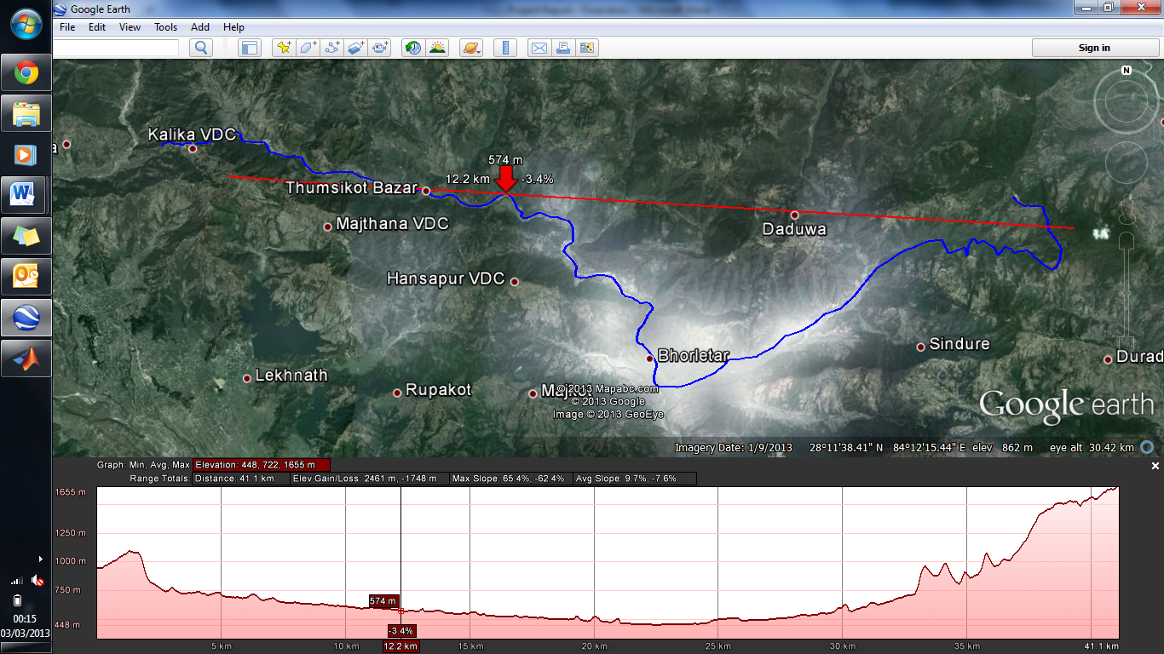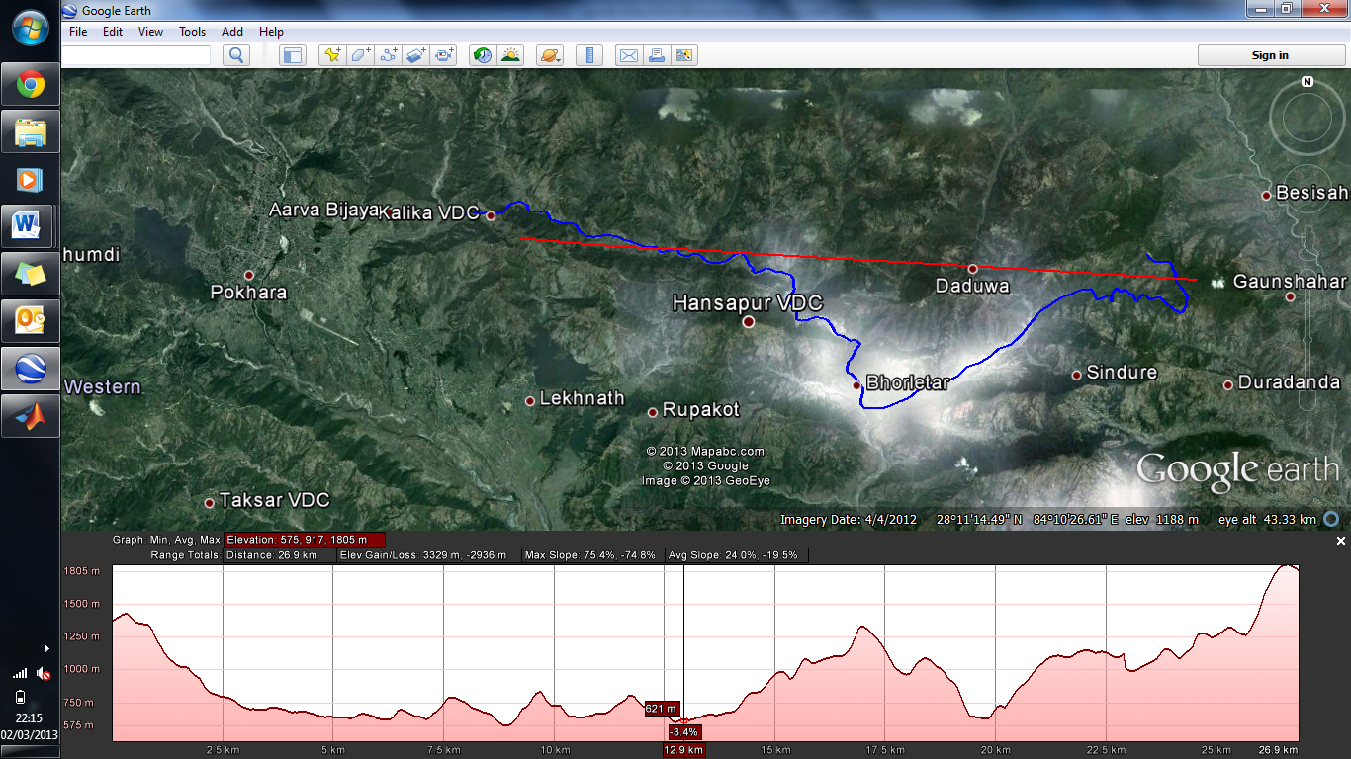

## Site Profile

The figure above shows a map of the proposed implementation area in Nepal. The red line on the map depicts the microwave transmission beaming path from the solar farm to the city of Pokhara. The blue path indicates a possible route for an overhead 33 kV distribution line from the same locations. The lower half shows the elevation profile along the transmission path (top) and the distribution line (bottom). The red star indicates the location of the transmitter array in Banglung Pani and the blue stars are possible locations for the receiving array.

## Line of Sight Calculations[15]

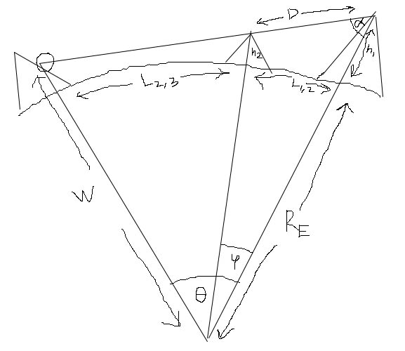

Transmitter

Receiver

Figure 6 – Line of Sight Reconstruction

Constants:

$h_{1}=1.819$ $h_{2}=1.283$ $L_{1,2}=9.7$ $L_{1,3}=26.02$ $R_{E}=6317$

Calculations:

$$θ=\frac{L_{1,3}}{R_{E}}=4.08413122×{10}^{-3}$$

$$φ=\frac{L_{1,2}}{R_{E}}=1.522523937× {10}^{-3}$$

$$D=\sqrt{{(R_{E}+h_{1})}^{2}+{(R_{E}+h_{2})}^{2}-2{(R}_{E}+h_{1})(R_{E}+h_{2})\cos{φ}}=9.71715481$$

$$α=\sin^{-1}\left(\frac{R_{E}+h_{2}}{D}\sin{φ}\right)=1.514846891$$

$$W=\frac{(R_{E}+h_{1})\sin{α}}{\sin{(π-α-θ)}}=6371.414722$$

To be able to transmit microwaves from the transmitter to the receiver line of sight is required. At the proposed site there is a mountain peak at 1283m in between transmitter peak at 1819m and the receiving peak at 1423m. To ensure that there is line of sight a straight beam must be able to pass over the central peak and project somewhere on the side of the receiving mountain. The construction above shows that such a beam would hit the receiving mountain at 414m however the slope leads to a plateau at 700m so the window available to place the receiving array is 723m (from plateau to mountain peak).

# Appendix B – Transmission Figures

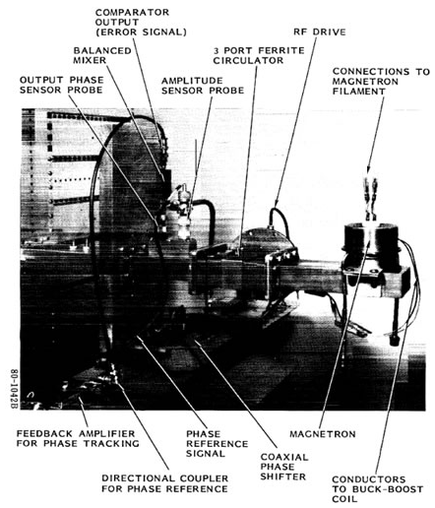

Figure 7 – Phase and Amplitude Tracking Control Circuit [21]

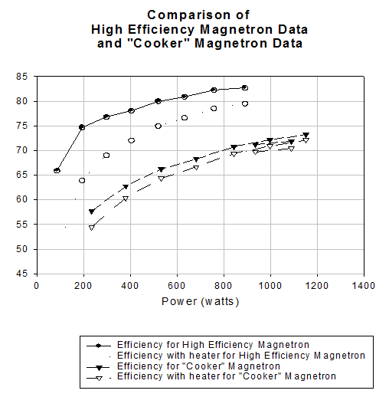

Figure 8 – Magnetron Efficiencies – [37]

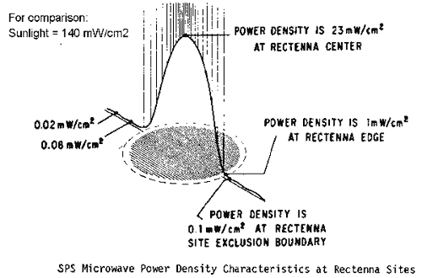

Figure 9 – SPS Microwave Power Density at Rectenna [http://www.permanent.com/solar-powersat-satellite-beam-environment-beam.html]

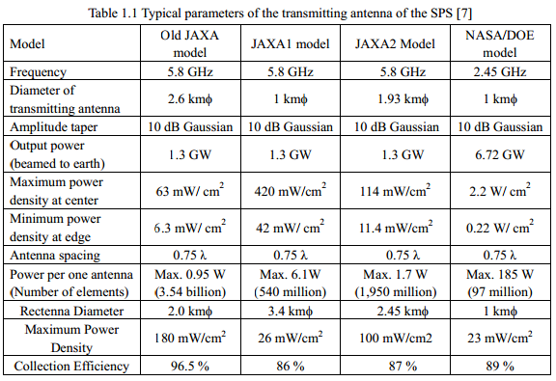

Figure 10 – Parameters of transmitting antenna for SPS [40]

# Appendix C – List of Variables used in Modelling

Table 2 – Weather Model Variables [26]

|  |  |  |
| --- | --- | --- |
| **Symbol** | **Variable** | **Description** |
| $$H_{oλ}$$ | Extra-terrestrial Irradiance | The intensity of solar irradiation directly outside the Earth’s atmosphere on a horizontal surface. This is a constant given in the paper for different wavelengths. |
| $$T_{rλ}$$ | Transmittance for Rayleigh S&A[16] | Scattering of light due to particles much smaller than the wavelength of light. These particles may be molecules or atoms. |
| $$T_{aλ}$$ | Transmittance for aerosol S&A | Attenuation of electromagnetic radiation due to aerosols. Aerosols are small particles suspended in the air and may include dust, droplets of salt water and greenhouse gases. |
| $$T_{wλ}$$ | Transmittance for Water Vapour S&A | Scattering and Absorption due to water vapour in the atmosphere. |
| $$T_{oλ}$$ | Transmittance for Ozone S&A | Attenuation of light caused by the ozone layer of the atmosphere. The ozone layer is formed of molecules with three oxygen atoms. |
| $$T_{uλ}$$ | Transmittance for Mixed Gas S&A | The term mixed gas includes carbon dioxide, carbon monoxide, nitrogen dioxide, methane and oxygen. |
| $$D$$ | Earth-Sun Distance | The mean distance between the Earth and Sun, also known as an Astronomical Unit (AU). |
| $$Z$$ | Solar Zenith Angle | The angle the Sun makes with a line perpendicular to the ground. When the Sun is directly overhead, Z = 0 ° |

Table 3 – Photovoltaic Cell Model Variables [30]

|  |  |  |
| --- | --- | --- |
| **Symbol** | **Variable** | **Description** |
| $$I$$ | Output Current | The total current output of the solar cell, taking into account loss. |
| $$I_{ph}$$ | Photocurrent | The current produced by the cell in response to indecent light. |
| $$I_{d}$$ | Diode current | The cell has diode-like properties, so some current is lost to its diode component. |
| $$I_{R}$$ | Series Resistance Current | The current lost in ohmic and parasitic losses between photo- and output currents. |
| $$I_{sc}$$ | Short circuit Current | A standard quoted parameter; the current flowing when there is no voltage applied across the cell. |
| $$I_{S}$$ | Saturation Current | Comes from the standard diode current equation; dependant on the semiconductor properties of the cell. |
| $$V$$ | Output Voltage | The voltage applied across the cell. |
| $$V_{oc}$$ | Open circuit Voltage | A standard quoted parameter; the voltage applied when the cell will output no current. |
| $$V_{th}$$ | Thermal Voltage | Comes from the standard diode current equation; dependant on the temperature of the cell’s junctions. |
| $$R_{S}$$ | Series Resistance | Resistance used to model the loss between photo- and output currents. |
| $$R_{sh}$$ | Shunt Resistance | Resistance used to model the loss over the voltage of the cell. |
| $$n, n'$$ | Ideality factor/ Diode quality factor | A measure of how ideal the diode is and how well it fits standard equations. $n'$ is the normalised factor used in some equations. |

Table 4 – Transmission Model Variables [39]

|  |  |  |  |
| --- | --- | --- | --- |
| **Friis Transmission Equation** | | | |
| **Symbol** | **Variable** | **Description** | **Maximum Demonstrated Value** |
| $$η_{T}$$ | Transmission Efficiency | Characterizes inefficiencies in the transmitter array during the DC to microwave power conversion in the magnetron and dipoles | 70-80% however is power and frequency dependant. |
| $$η_{Beam}$$ | Beaming Efficiency | Efficiency of the microwave beam between the transmitter and receiver array also taking into account propagation losses. | 80% |
| $$PCE$$ | Power-combining Efficiency | Efficiency of the transmitter combiner. As each array element will only transmit a fraction of the required power they need to be combined into a single antenna. | 80-90% |
| $$η_{Rect}$$ | Rectification Efficiency | Efficiency of the rectenna in converting microwave power to DC power at the receiver. | 80% |
| $$η_{PM}$$ | Rectenna Power Management | Efficiency of the rectenna in producing a regulated fixed output voltage which can be used to charge flow battery. | 85-90% dependant on rectenna number and power. |
| $$η_{A}$$ | Atmospheric Absorption Factor | Absorption coefficient of microwave radiation in free space. | 98% at 2.45GHz |
| $$D_{T,R}$$ | Directivity | The directivity of the transmitter and receiver array. | N/A |
| $$R$$ | Distance | The distance between transmitter and receiver. | N/A |
| $$λ$$ | Wavelength | The wavelength of transmission. | 0.122m at 2.45GHz |
| **Directivity Equation** | | | **Range** |
| $$U(θ,ϕ)$$ | Electric Field | Electric field due to array elements | N/A |
| $$θ$$ | Theta | Vertical sweep across array | $$0-π$$ |
| $$ϕ$$ | Phi | Horizontal sweep across array | $$0-2π$$ |

# Appendix D – Mathematical Model Output

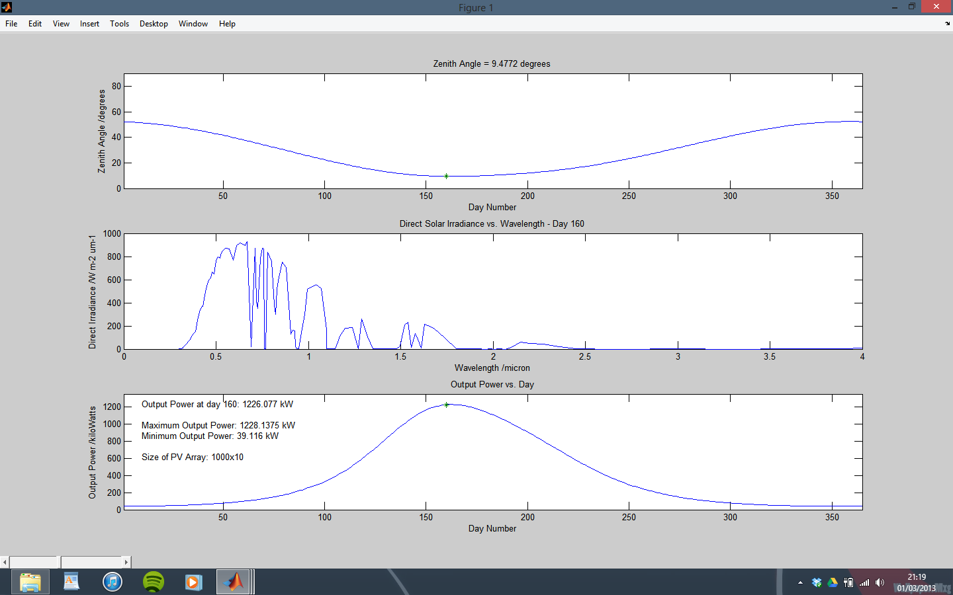

Figure 11 – Weather and PV Model Output for Proposed Solar Power Plant Site at Banglung Pani.

1. Solar power potential in Nepal detailed in Feasibility Section
2. Detailed in the Technical Research section
3. Figures reflect performance at peak irradiance.
4. The performance of a PV panel is measured in kilowatt hours per kilowatt peak, which is the number of electrical units of energy (kWh) the panel will produce at a maximum output (kWp), or during the brightest sunlight.
5. Figures assume 4kW system design
6. Refer to Figure 6 in Appendix B
7. Exchange rate of 1 GBP = 1.5165 USD
8. http://www.ee.ic.ac.uk/thomas.priddle11/yr2proj/home.html
9. Refer to Appendix D Figure 9
10. Refer to Appendix A for detailed site information.
11. Refer to Irradiance plot in Appendix C.
12. Detailed in Friis Equation
13. Figures reflected calculated values using sourced material with an additional 20% overhead.
14. Refer to Appendix B Figure 7 for illustration of effect.
15. All values in kilometres unless specified.
16. S&A: Scattering and Absorption